**CS325 Group Project   
Assignment #2**

|  |  |  |  |  |
| --- | --- | --- | --- | --- |
| **Group** | **DigiPen Student ID** | **SIT Student ID** | **Student Full Name** | **DigiPen Email** |
| 3 | 440006319 | 1900798 | Chong Jin Kiat | jinkiat.chong@digipen.edu |
| 440002719 | 1900860 | Cheah ChenXuan Shawn | c.chenxuanshawn@digipen.edu |
| 440006019 | 1902783 | Law Zhi Xuan | zhixuan.law@digipen.edu |
| 440000819 | 1900813 | Tian Yu | t.yu@digipen.edu |
| 440000119 | 1900806 | Goh Wei Zhe | weizhe.goh@digipen.edu |

Introduction

We are Buixel, and we believe in using AR to enhance the daily online lives of people.

Our company focuses on two target groups, merchants and consumers. With the increase in demand for online shopping, e-commerce merchants naturally have to stay in touch with their consumers more than ever.

With more consumers purchasing products online, problems such as product listing accuracy would arise. With Buixel, we aim to remove such issues with our 3D Augmented Reality technology. Having us increases the authenticity of merchants, and the confidence in their consumers.

Buixel operates on our own application, and e-commerce companies can partner with us to integrate our system into their platforms. Having the ability to scan their products into a 360-degree 3D model view allows consumers to access them easily through our application with high accuracy.

User Analysis

# Target Class

* General Public
* Merchants

# Characteristics

* Individuals who prefer online purchase
* Target age group between 17 - 50+
* Individuals who sell items online

# Personas

* Kaite is a 30-year-old female online e-merchant in Singapore
* Daren is a 17-year-old male student starting an entrepreneur in e-commerce market
* Justin is a 29-year-old male working at a hotel as hotel manager
* Qiyi is a 35-year-old female housewife with 2 kids in the family

# Survey

We have sent out surveys to participants ranging from all age groups. Below are the results collected from the survey over a period of weeks from the participants.

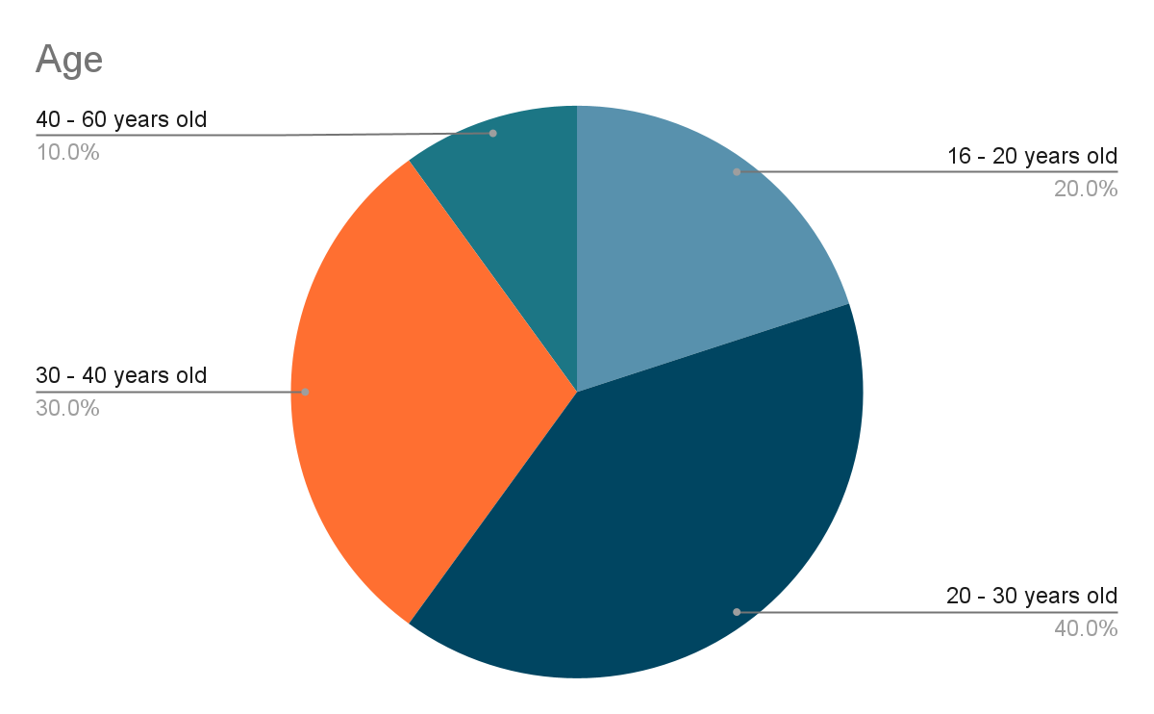

*Figure 1. The age group which participated in our survey*

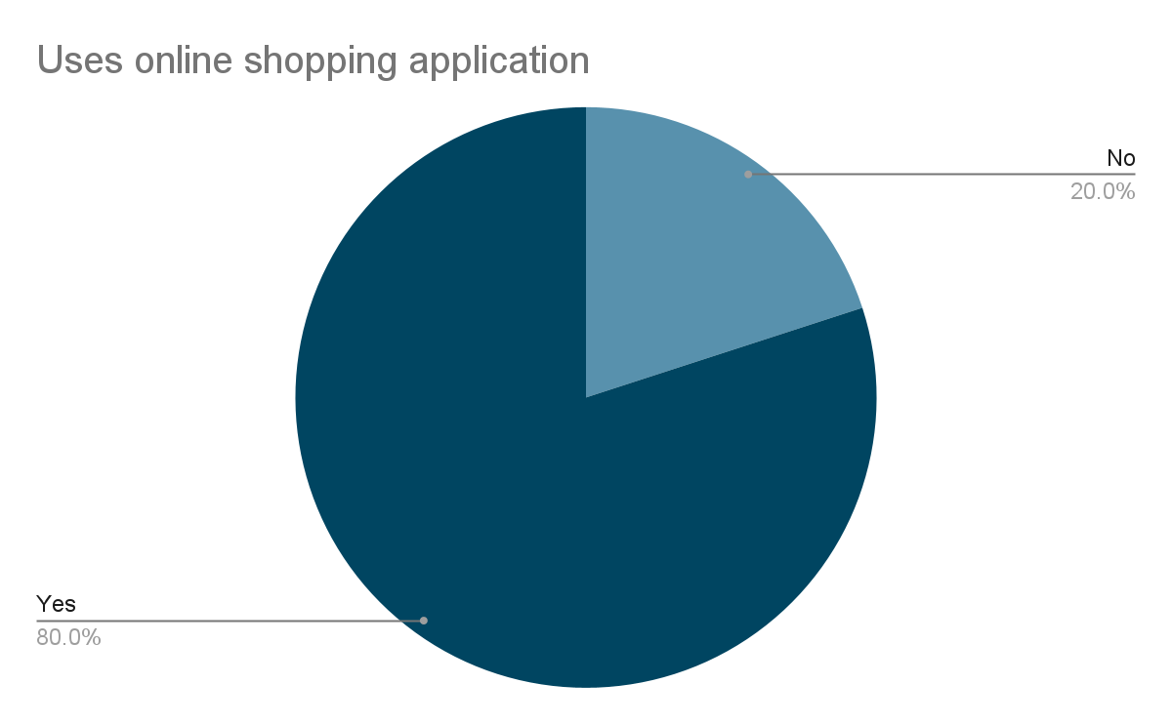

*Figure 2. The percentage of participant using online shopping applications.*

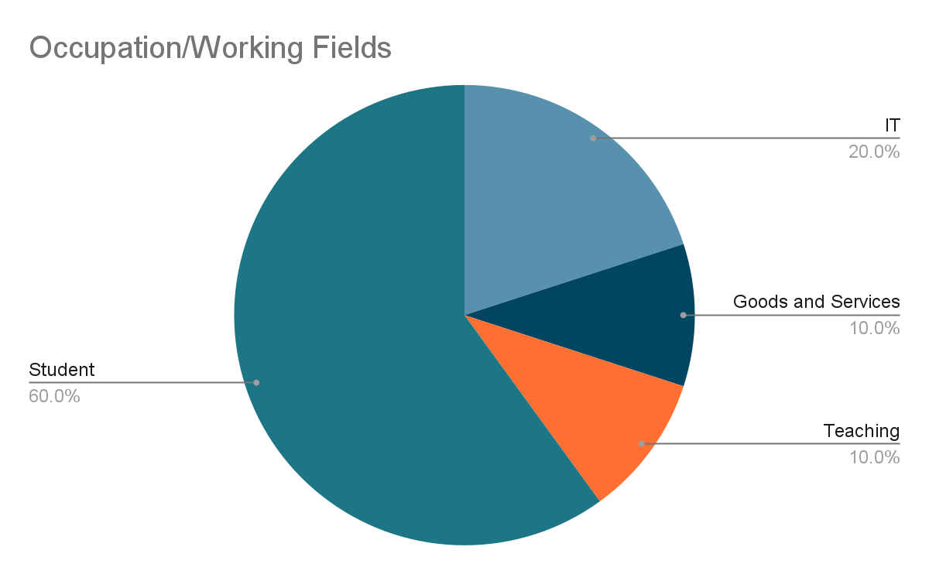

*Figure 3. The participants workforce industry.*

# Research

## Increasing Trend of E-Commerce Sales

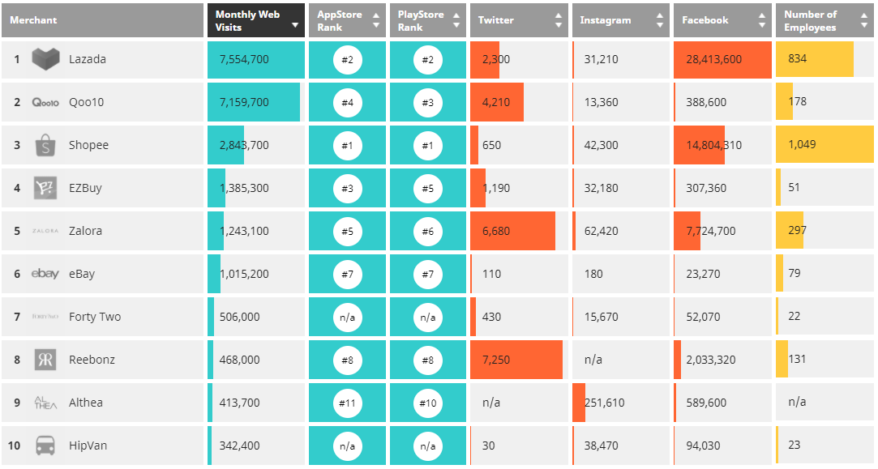

*Table 1. Singapore E-commerce company statistics from Q2 2019*

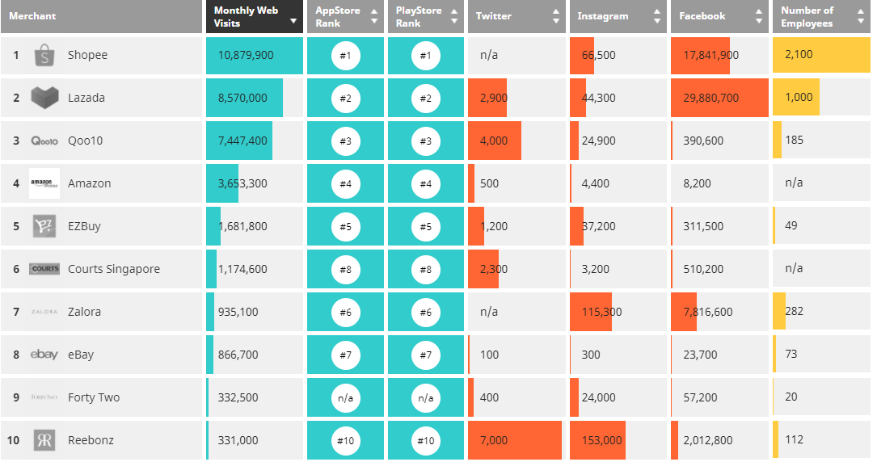

*Table 2. Singapore E-commerce company statistics from Q2 2020*

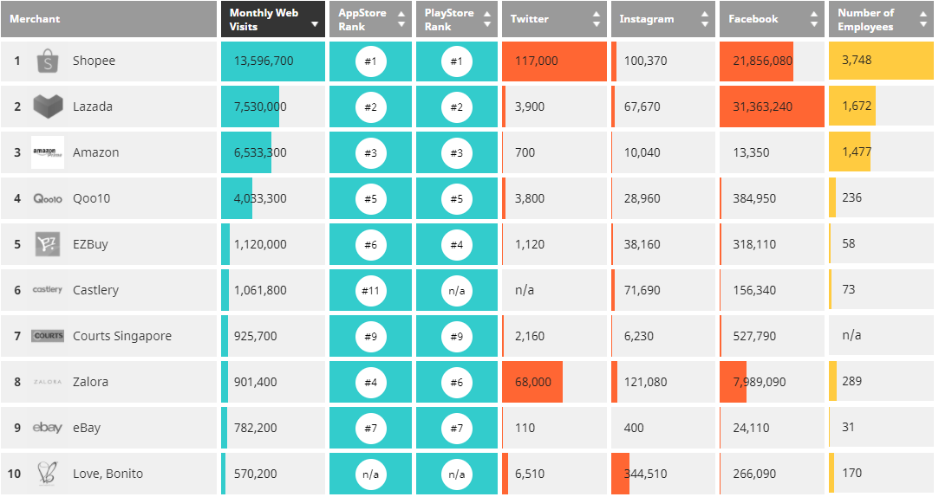

*Table 3. Singapore E-commerce company statistics from Q2 2021*

From the statistics presented by *iPrice Insights* *2021.* Since 2019, E-commerce platforms in Singapore have witnessed an increasing sales growth and site visits. Between January to June 2020, Singaporeans have spent an average of $113 on a single online transaction only.

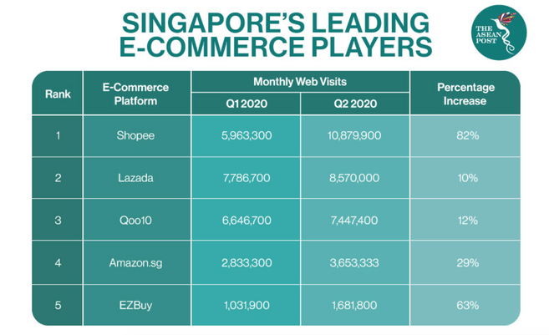

*Table 4. Changes in monthly web visits between the different platforms*

Within 1 year, *Shopee* saw an increase of 82% in the number of users. gaining nearly 5 million new visitors in the second quarter of 2020. E-commerce is slowly integrated into the lives of many people, and we can only expect them to keep growing with the advancement of technology.

## 

## Online purchases complaints

Consumers purchase faulty goods which end up complaining.

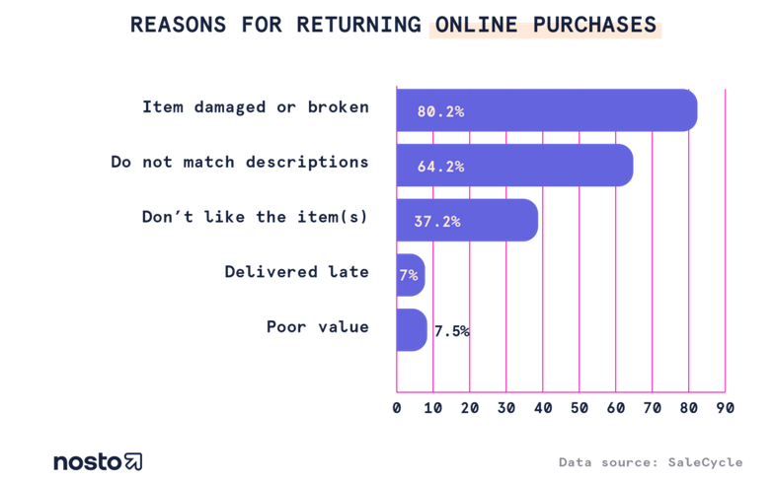

*Table 5. Reasons why consumers are returning online purchases*

The graph above shows the top reasons why customers return products. Over 64% of the online purchases do not match descriptions and leave consumers dissatisfied. When consumers have such experiences on a particular platform, it might discourage them from purchasing more items online and might share their awful experience with online purchasing.

# Interview / Questionnaires

We have chosen 3 participants that are the closest to our targeted personas to interview them regarding their online shopping experiences and the following design idea.

Buixel is a software that allows you to see products through an Augmented Reality (AR) interface, where you can observe your product through an augmented environment with your mobile devices / AR goggles.

## 

## Interviewee Background

|  |  |  |  |
| --- | --- | --- | --- |
| **Name** | Truman | Irfan | Kai Li |
| **Age** | 25 | 24 | 33 |
| **Gender** | Male | Male | Female |
| **Occupation** | Market Research Surveyor | Student | Banking Executive |

## Interview Question & Answer

|  |  |
| --- | --- |
| **Participant Name** | **How often do you purchase items online?** |
| Truman | 3 - 4 times per month |
| Irfan | At least once a month |
| Kai Li | A few times per week. |

|  |  |
| --- | --- |
| **Participant Name** | **Which shopping app do you use the most?** |
| Truman | Shopee |
| Irfan | Carousell |
| Kai Li | Shopee and Lazada |

|  |  |
| --- | --- |
| **Participant Name** | **What do you like and what do you hate about their app?** |
| Truman | I like that the UI is easy to navigate around. But their layout and the variety of options available are messy and confusing for me |
| Irfan | The shopping apps are convenient to use, and features are easy to understand.  However, some pictures do not showcase the product properly and I can’t tell the quality of the product. |
| Kai Li | Their UI is intuitive. Too many features offered thus cluttering the main page when I only want to look at products that are on sale. |

|  |  |
| --- | --- |
| **Participant Name** | **Will you be interested to see your product in a augmented environment to better view the product quality before purchasing them?** |
| Truman | Yes |
| Irfan | Yes, it would let me know more about the products before purchasing them. |
| Kai Li | Yes, this will prevent a lot of refunds issues with items not looking as described which I have with items I had purchased before. |

|  |  |
| --- | --- |
| **Participant Name** | **What are the types of additional features would you like to see in Buixel?** |
| Truman | Viewing the products in different lighting. |
| Irfan | Zooming in and out. Able to select multiple items to view at once to prevent navigating back and forth a single app.  This allows me to compare similar products |
| Kai Li | Reward system, as a loyal customer I would like to have some sort of benefits for using the app over a period of time. |

|  |  |
| --- | --- |
| **Participant Name** | **What are the fears/confusion you have about Buixel for example *(Hard to use / inconvenient to use)*?** |
| Truman | The app may require a large amount of storage space to download and load the product in high detail. |
| Irfan | Quality of the 3D image. |
| Kai Li | Due to phone software limitations, it might not be able to support the application. |

|  |  |
| --- | --- |
| **Participant Name** | **Do you think having a button to view the product in Buixel when browsing through different products in the shopping app is intuitive enough?** |
| Truman | Yes, it’s easy to access and to view shopping apps. There could be an extension for browser usage as well. |
| Irfan | Yes, it is simple and intuitive to understand. |
| Kai Li | Yes, it will be easy to access and view the product. |

|  |  |
| --- | --- |
| **Participant Name** | **Do you sell any items online?** |
| Truman | No. |
| Irfan | Yes, occasionally |
| Kai Li | Yes, quite often |

|  |  |
| --- | --- |
| **Participant Name** | **Would you be interested to try out this AR platform to sell your items in the future?** |
| Truman | I would if the platform is easy to set up and use as a merchant. |
| Irfan | Yes, most of the time buyers have always requested for more photos of the product and with this app, such an issue can be avoided. |
| Kai Li | Yes, allowing my buyers to see my product in 360 degrees will let them know that the item I’m selling is as described on the product page. |

|  |  |
| --- | --- |
| **Participant Name** | **Looking at this image, do you think this is a convenient way to scan the item? If not, do you have any other suggestions?** |
| Truman | It would be convenient if the product is small, however the process might be a hassle if the product is huge *(I.E Sofa, Fridge)* |
| Irfan | I don’t mind spending extra time to ensure my item is properly showcased to my buyers. |
| Kai Li | When I have multiple items to scan, such a process might be a hassle |

|  |  |
| --- | --- |
| **Participant Name** | **If you are a vendor, what are your fears about selling items on our platform?** |
| Truman | The app might be buggy thus chasing potential customers.  App might not be secured and might be subjected seller to an important information leak. |
| Irfan | Item protection fees and the process of refunding. Will seller’s rights be protected by the platform like how the existing shopping app is protecting their seller from frauds and bots. |
| Kai Li | This platform might not receive as much popularity compared to the shopping app platform existing right now. |

Following the results from the interview, we have concluded that both merchants and consumers are willing and interested to give Buixel a try. However, both parties are sceptical of the features and popularity of the application. To ensure customers stay on our platform, Buixel focuses on providing a satisfactory application with reward systems to retain our new and existing customer base. Reward system includes *(but not limited to)* lucky draws, cheap sales, and voucher rewards.

Task Analysis

3 Main Tasks:

1. Consumers using phones to access the Buixel application to view the 3D models
2. Consumers using AR goggles to view the products in their environments
3. Merchants using Buixel application to scan and upload

# Consumers Accessing Buixel via Phones

|  |  |
| --- | --- |
| Goal | Consumers using phones to access the Buixel application to view the 3D models. |
| Users | Consumers |
| Preconditions | 1. A smartphone that enables web surfing. 2. To have an existing Buixel account 3. Their account username and password 4. 3D models of items they want to purchase are uploaded prior to 3rd party online platforms by merchants. |
| Subtasks | 1. Enter Buixel application 2. Create a new Buixel account for new users 3. Login account for existing users 4. Browse homepage to view all products 5. Enter keywords to search for specific products |
| Task performed | Can be performed anywhere accessible to the network |
| Environment | Comfort of the users’ homes |
| Time / Resource Constraints | Take a few seconds to open Buixel application |
| Who else is involved | None |
| What can go wrong | 1. Technical errors within the application 2. User forgot username and password 3. Users enter wrong product 4. Users enter wrong payment options 5. Merchants not uploading good 3D models |
| Techniques observed | * Observation   + Getting people to utilize our application live and observe their reaction * Interviews   + Asking people what their thoughts on the Buixel application are * Surveys and Questionnaires   + Conduct online surveys to find out what people think of the Buixel application anonymously   + Using online surveys with not too many questions, but good questions   + Such surveys can be tracked easily for data analysis   + Able to reach a wider audience   + Errors can be corrected easily * Data Logging   + Saving the information of how people interact with the application to improve on the user friendliness   + Saving data to see how easy it is to do a repetitive purchase after the first time   + Saving data to see the retention rate of the application |

# Consumers Accessing Buixel via AR goggles

|  |  |
| --- | --- |
| Goal | Consumers using AR goggles to view the products in their environments |
| Users | Consumers |
| Preconditions | 1. A physical Augmented Reality (AR) goggles 2. To have an existing Buixel account 3. Their account username and password 4. 3D models of items they want to purchase are uploaded prior to 3rd party online platforms by merchants. |
| Subtasks | 1. Connect AR goggles to internet 2. Access Buixel app 3. Create a new Buixel account for new users 4. Login account for existing users 5. Browse homepage to view all products 6. Enter keywords to search for specific products |
| Task performed | Can be performed anywhere accessible to the network. |
| Environment | Comfort of the users’ homes |
| Time / Resource Constraints | Takes time to set up AR goggle |
| Who else is involved | None |
| What can go wrong | 1. Misplaced of AR goggles 2. Syncing of AR goggles to web 3. Malfunction of AR goggles 4. User forgot username and password 5. Users enter wrong product 6. Users enter wrong payment options 7. Merchants not uploading good 3D models |
| Techniques observed | * Observation   + Getting people to utilize our application live and observe their reaction * Interviews   + Asking people what their thoughts on the Buixel application are * Surveys and Questionnaires   + Conduct online surveys to find out what people think of the Buixel application anonymously   + Using online surveys with not too many questions, but good questions   + Such surveys can be tracked easily for data analysis   + Able to reach a wider audience   + Errors can be corrected easily * Data Logging   + Saving the information of how people interact with the application to improve on the user friendliness   + Saving data to see how easy it is to do a repetitive purchase after the first time   + Saving data to see the retention rate of the application |

# Merchants Utilizing Buixel

|  |  |
| --- | --- |
| Goal | Merchants use the Buixel application to scan and upload. |
| Users | Merchants |
| Preconditions | 1. Having an account to Buixel 2. Incorporating Buixel into their e-commerce application 3. Have a smart device (i.e., phones) to capture the 3D images of the products 4. Gain approval from Buixel to verify the products to be showcased |
| Subtasks | 1. Create a Buixel account 2. Select partnership with Buixel (as a merchant) 3. Connect the Buixel application with the selected e-commerce application 4. Select a product to scan, upload the scanned images to Buixel 5. Fill in the necessary details for verification |
| Task performed | 1. At the comfort of the merchant’s home or office 2. At our headquarters to assist with 3D scanning |
| Environment | Comfort of the user’s choice of location |
| Time / Resource Constraints | 1. Takes a few minutes to hours (depending on the products) for scanning 2. Takes a few minutes for Buixel to verify |
| Who else is involved | None |
| What can go wrong | 1. 3D scanning not done properly 2. Product denied through verification (i.e., offensive product) 3. Product details not set up correctly. |
| Techniques observed | * Observation   + People can come to our headquarters to be assisted with 3D scanning   + They would be observed at how well the process is * Interviews   + Live interviews would be conducted to see how easy merchants feel when connecting to Buixel and scanning of products   + Finding out if merchants needed assistance to scan for the first time, would the process be easy enough for them to not need assistance for future implementations * Surveys and Questionnaires   + Anonymous online surveys would be requested for merchants who use Buixel   + Using online surveys with not too many questions, but good questions   + Such surveys can be tracked easily for data analysis   + Able to reach a wider audience   + Errors can be corrected easily * Data Logging   + Saving the information of how merchants interact with the application to improve on the user friendliness   + Saving data to see how easy it is to do a repetitive 3D scan and upload of product after the first time   + Saving data to see the retention rate of the application |

# In-depth Analysis of our Observation

Before the launch of Buixel application, potential consumers across all ages above 18 as well as collaborated merchants will be constantly invited at our recording sites to record and observe their experience using Buixel application with the use of phone and AR goggles, then followed up with an interview.

The main focus for consumers will be analysing the full process of how each age group uses the respective device to successfully view and cart out the items they want to purchase without any external help. This will help us to identify the needs of each age group such as older generations may not be familiar with the use of AR goggles. On the other hand, for merchants, we will be taking note of the full process of them using their phones to scan the product and upload their 3D model into the Buixel application without any guidance. We will be able to identify the total time spent and the problems they face as a merchant. Through observation and recordings, it helps the team to implement new and better features to rectify current issues for better user experience.

# In-depth Analysis of our Interviews

Structured Interviews will be conducted in person after consumers and merchants have their first-hand experience with the Buixel application. The interview will be audio recorded prior to their permission for the company to do in-depth research without having to expose their identities.

The purpose of such interviews is to obtain firsthand opinions of their experience with the application such as understanding the problems that users encounter, analyse the market users and improve on making the application standout among others.

# In-depth Analysis of our Surveys

In our lists of surveys, we are looking towards online surveys where responses can be tracked, and we can aim to reach a wider audience. Through such surveys, data analysis would be easier and any errors in the survey can be rectified quickly.

For simplicity, we would choose the Likert scale for our surveys. In comparison to the Semantic Differential scale, the Likert scale is less abstract and easier for participants to understand. Using the Semantic Differential scale could require a higher cognitive demand from the participants due to the abstract levels of the questions.

Following the core concept behind online surveys, our questionnaires would have short, but good questions. We will ensure anonymity and have a clear point to get to.

We are aware of the issues that online surveys have. Examples include low response rate, response bias, and users being dishonest. However, regardless of what kind of survey is being used, dishonesty is something that we cannot prevent. Therefore, we are looking for easier and straightforward surveys that would be easier for participants to use, making them more prone to be honest in their comments.

# In-depth Analysis of our Data Logging

The main purpose of using data logging is for us to keep track of how users (both consumers and merchants) interact with Buixel.

For consumers, the main part to log is the number of clicks needed to fully complete the use of viewing the 3D models from the e-commerce application to Buixel. This is to track how long it takes for users to experience and utilize our application. With a large amount of data recorded, we would be able to improve the user friendliness of Buixel.

For merchants, we would be logging the time taken for them to scan their products, to verify and upload to Buixel. Due to the plethora of products merchants would have, it is of importance to allow a good and easy process to use our application. Having a quick and easy process allows merchants to use Buixel more.

Domain Analysis

# For Merchants:

Sell an item

Download

Buixel scanning app

Use the app

to scan the item(s)

Write product description

Publish

product page onto website

0.

1.

2.

3.

4.

Upload

scanned models

Upload

pictures

Click on

‘Publish’ button

4.1

4.2

4.3

Capture

item(s) on your phone with camera

Orbit around

the item(s)

Preview the

3D scanned model

2.1

2.2

2.3

Click on the

link to download Buixel

App store or

Google Play will launch

Download and Install

1.1

1.2

1.3

Accept terms

and conditions

1.4

Plan 0.

If Buixel App is installed, do 2.

then 3 - 4

Plan 1.

1.1 - 1.2 - 1.3 - 1.4

Plan 2.

2.1 - 2.2 - 2.3

Plan 4.

4.1 - 4.2 - 4.3

*Figure 4. Domain Analysis from a merchant perspective.*

# For Consumers:

Buy an item

Search for

an item

Click on the

product page

Download

Buixel App

View 3D Model of item

0.

1.

2.

3.

4.

Swipe to

rotate the model

4.1

Tap on

the search bar

Type the

item name

1.1

1.2

Plan 0.

1 2 3 4 Does item fulfil needs? 5

Plan 1.

1.1 - 1.2

Plan 4.

4.1

Purchase item

5.

Click on the

link to download Buixel

App store or

Google Play will launch

Download and Install

3.1

3.2

3.3

Accept terms

and conditions

3.4

Plan 3.

3.1 - 3.2 - 3.3 - 3.4

Yes

No

*Figure 5. Domain Analysis from a Consumer perspective.*

# In-depth Domain Analysis

Buixel offers to cater to both the merchants and consumers' needs respectively. Creating an application which is intuitive and easy to use for both parties. A few key points that we have identify are the following

* Functionality of the application.
* Intuitiveness of the application.
* Accessibility to the application.

## Functionality of the Application

Buixel aims to offer multiple functionalities depending on whether you are a merchant or a consumer.

**A merchant** should be able to scan their products with ease, the product should be displayed on our platform in high detail without the necessity of purchasing additional scanning equipment. They should be able to view multiple products easily without unnecessary clicks or troublesome navigation in the application.

**A consumer** should be able to filter out products based on their wants. Filter will include price range, materials, top sales and multiple options to choose from. Products should be augmented to their environment, so they are able to choose the best option available for themself.

## Intuitiveness of the Application

Both merchants and consumers must be able to navigate through the system with ease. Buttons and UI on the front page serve to guide them to the multiple features we have installed for them and should not confuse them.

## Accessibility of the Application

To use Buixel, software limitations should be kept to a minimum to accommodate users with lesser hardware capabilities. This to ensure fairness across our user base and no one should be disqualified from using our application due to such a limitation. We aim to further improve this by creating cheaper alternatives in the event that a user is not able to display an augmented reality to their environment by at least allowing them to view the product on their home devices and the ability to look at the details of a product in high quality.